EXPT NO:1 | Implementation of data charts
DATE: 06.01.2026 | Implementation of data charts

PRE-LAB QUESTIONS (PROVIDE BRIEF ANSWERS TO THE FOLLOWING QUESTIONS)

- How can visualization help an academic institution improve student outcomes?
Visualization transforms raw academic data into meaningful graphical insights, helping institutions easily identify weak subjects, declining performance trends, and high-risk students. This enables timely academic interventions such as remedial classes, mentoring, and curriculum adjustments, ultimately improving student outcomes.

- Which chart types are suitable for comparing subject-wise performance?
Bar charts and column charts are most suitable for subject-wise performance comparison because they clearly display differences in average marks across multiple subjects. They allow quick visual comparison and help identify subjects with high or low performance.

- What type of data scale is used for student marks?
Student marks are measured on a ratio scale, as they have a true zero point (zero marks indicate no score) and equal intervals between values. This allows meaningful mathematical operations such as addition, averaging, and comparison.

- Why should raw academic data be cleaned before visualization?
Raw academic data may contain missing values, duplicate records, or incorrect entries that can distort visual outputs. Data cleaning ensures accuracy, consistency, and reliability, leading to correct interpretation and meaningful visual insights.

- How does visualization support evidence-based decision making?
Visualization presents data in a clear and intuitive format, allowing stakeholders to base decisions on actual performance trends rather than assumptions. It supports data-driven planning by highlighting patterns, correlations, and areas requiring improvement.
IN-LAB EXERCISE:

OBJECTIVE:
To design appropriate data charts to analyse and compare academic performance indicators.

SCENARIO:
An autonomous engineering college wants to analyse internal assessment performance of first-year students across five subjects to identify difficult courses and improve teaching strategies.

IN-LAB TASKS (Using R Language)

- Load required R libraries (ggplot2, dplyr)
Code:
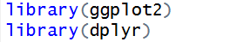

Output:
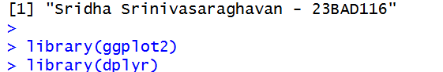

- Import dataset using read.csv()
Code:
Output:
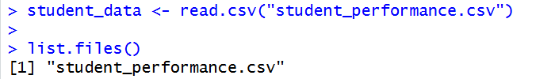

- Perform basic data preprocessing
Code:
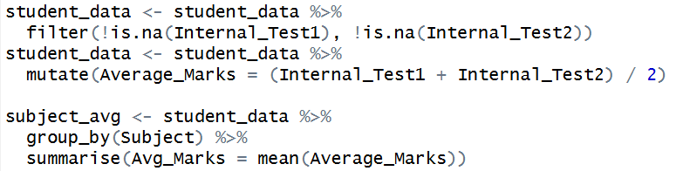
Output:
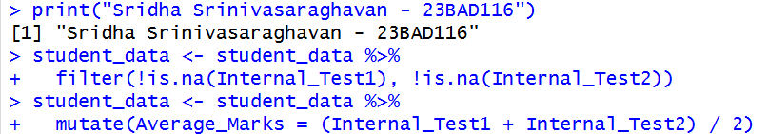

- Create bar chart for subject-wise average marks
Code:
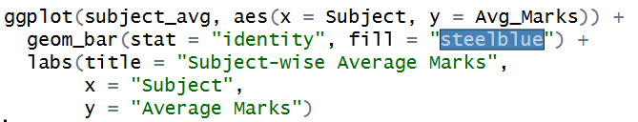
Output:
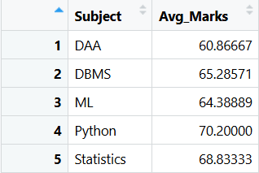
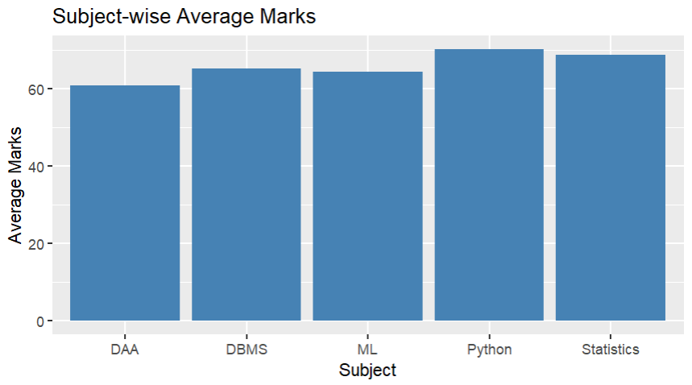
- Generate line chart for performance trend across tests
Code:
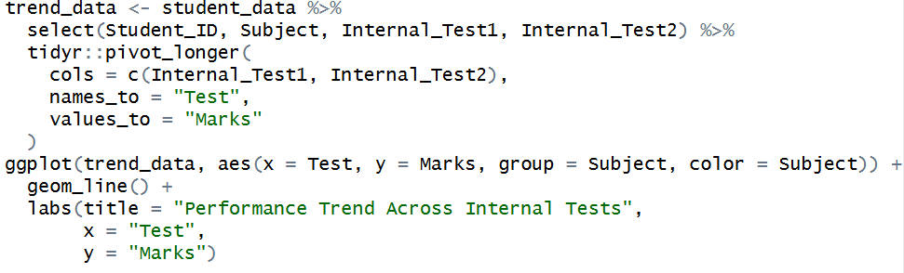
Output:
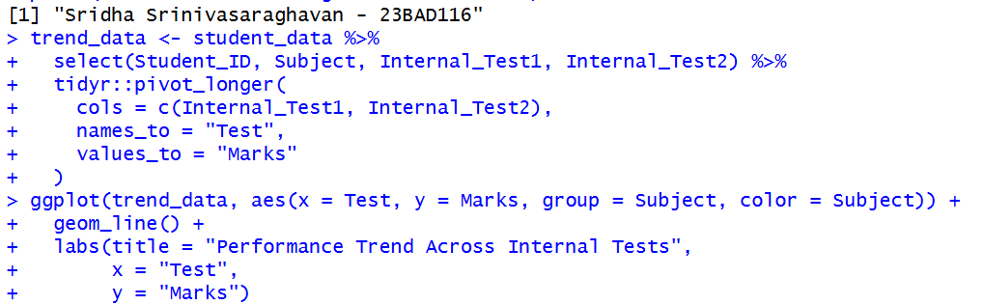

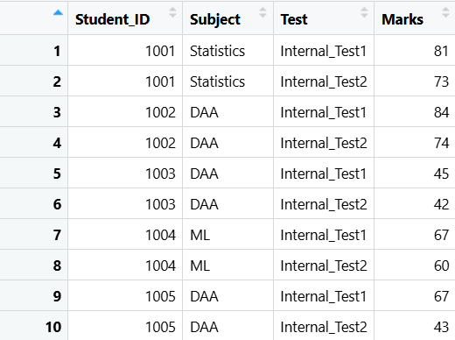
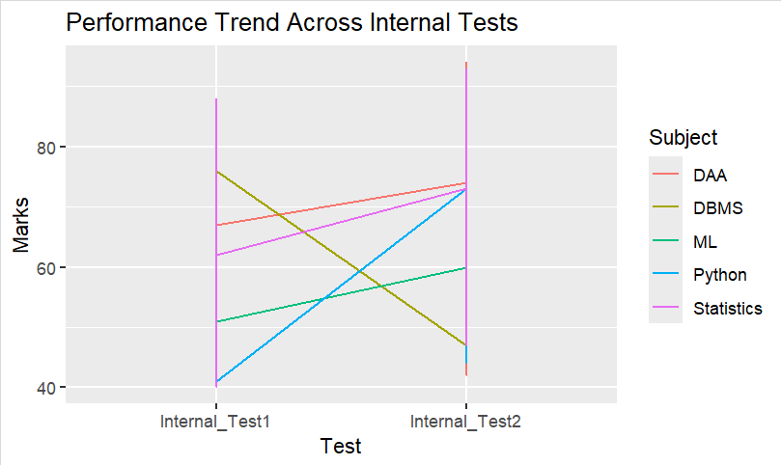

- Plot pie chart for grade distribution
Code:
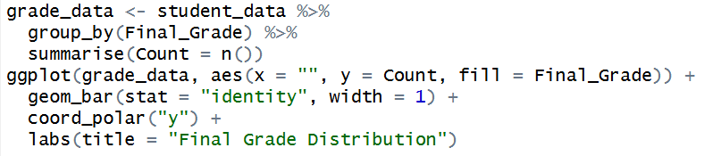
Output:
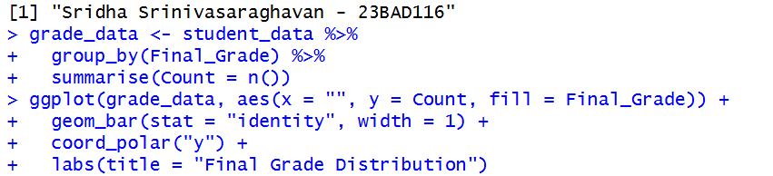
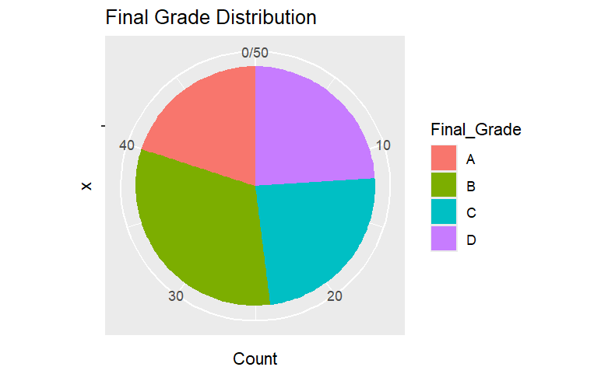

POST-LAB QUESTIONS (PROVIDE BRIEF ANSWERS TO THE FOLLOWING QUESTIONS)

- Which subject shows consistently low performance and why?
The subject with the lowest average marks across multiple assessments indicates consistently low performance. This may be due to higher subject difficulty, conceptual complexity, ineffective teaching methods, or insufficient learning resources.

- Why is a line chart suitable for trend analysis?
A line chart effectively displays changes in performance over time by connecting data points in sequence. It helps visualize trends, fluctuations, and progress across multiple internal assessments, making it ideal for analysing performance evolution.

- What limitations does a pie chart have in analytics?
Pie charts make it difficult to compare small differences between categories and become less effective when too many segments are present. They do not show trends or precise values, limiting their analytical depth.

- How can this analysis help curriculum planning?
This analysis helps academic planners identify difficult subjects and performance gaps, enabling syllabus restructuring, additional instructional support, and improved teaching strategies to enhance overall academic effectiveness.

- How can such visualizations be integrated into AI-driven academic analytics
Visualizations can be integrated with AI models to support predictive analytics, early student risk detection, and personalized learning recommendations. AI-driven dashboards can continuously monitor performance and suggest targeted interventions in real time.

ASSESSMENT
Description | Max Marks | Marks Awarded
Pre Lab Exercise | 5
In Lab Exercise | 10
Post Lab Exercise | 5
Viva | 10
Total | 30
Faculty Signature

